**Android Lab: 05/01/22**

**Q. Option**

**MainActivity.java**

package com.example.a5_1_22;

import androidx.appcompat.app.AppCompatActivity;

import android.content.Intent;

import android.os.Bundle;

import android.view.Menu;

import android.view.MenuItem;

import android.widget.Toast;

public class MainActivity extends AppCompatActivity {

@Override

protected void onCreate(Bundle savedInstanceState) {

super.onCreate(savedInstanceState);

setContentView(R.layout.activity_main);

}

//option menu

@Override

public boolean onCreateOptionsMenu(Menu menu){

getMenuInflater().inflate(R.menu.menu, menu); //R.xml file name.object name

return true;

}

@Override

public boolean onOptionsItemSelected(MenuItem item){

switch (item.getItemId()){

case R.id.item1:

Toast.makeText(getApplicationContext(), "About",Toast.LENGTH_SHORT).show();

Intent i=new Intent(MainActivity.this, MainActivity2.class);

startActivity(i);

return true;

case R.id.item2:

Toast.makeText(getApplicationContext(), "Help", Toast.LENGTH_SHORT).show();

return true;

default:

return super.onOptionsItemSelected(item);

}

}

}

**MainActivity2.java**

package com.example.a5_1_22;

import androidx.appcompat.app.AppCompatActivity;

import android.os.Bundle;

public class MainActivity2 extends AppCompatActivity {

@Override

protected void onCreate(Bundle savedInstanceState) {

super.onCreate(savedInstanceState);

setContentView(R.layout.activity_main2);

}

}

**menu.xml**

<?xml version="1.0" encoding="utf-8"?>

<menu xmlns:app="http://schemas.android.com/apk/res-auto"

xmlns:android="http://schemas.android.com/apk/res/android">

<item

android:id="@+id/item1"

android:title="About"

/>

<item

android:id="@+id/item2"

android:title="Help" />

</menu>

**Output**

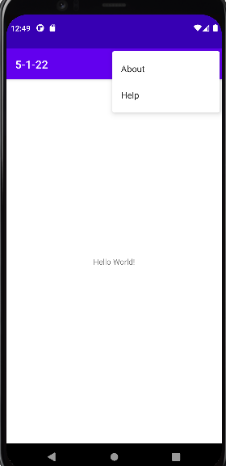 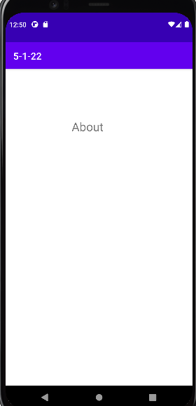

**Q. Listview**

**MainActivity.java**

package com.example.listview;

import androidx.appcompat.app.AppCompatActivity;

import android.os.Bundle;

import android.view.View;

import android.widget.AdapterView;

import android.widget.ArrayAdapter;

import android.widget.ListView;

import android.widget.Toast;

public class MainActivity extends AppCompatActivity {

ListView lv;

String countries[]={"India","China","US"};

@Override

protected void onCreate(Bundle savedInstanceState) {

super.onCreate(savedInstanceState);

setContentView(R.layout.activity_main);

lv=findViewById(R.id.lv);

ArrayAdapter arrayAdapter=new ArrayAdapter<String>(MainActivity.this, R.layout.support_simple_spinner_dropdown_item, countries);

lv.setAdapter(arrayAdapter);

lv.setOnItemClickListener(new AdapterView.OnItemClickListener() {

@Override

public void onItemClick(AdapterView<?> parent, View view, int position, long id) {

Toast.makeText(getApplicationContext(), "you clicked "+countries[position], Toast.LENGTH_SHORT).show();

}

});

}

}

**activity_main.xml**

<?xml version="1.0" encoding="utf-8"?>

<androidx.constraintlayout.widget.ConstraintLayout xmlns:android="http://schemas.android.com/apk/res/android"

xmlns:app="http://schemas.android.com/apk/res-auto"

xmlns:tools="http://schemas.android.com/tools"

android:layout_width="match_parent"

android:layout_height="match_parent"

tools:context=".MainActivity">

<ListView

android:id="@+id/lv"

android:layout_width="331dp"

android:layout_height="228dp"

android:layout_marginStart="40dp"

android:layout_marginTop="68dp"

android:layout_marginEnd="40dp"

android:layout_marginBottom="435dp"

app:layout_constraintBottom_toBottomOf="parent"

app:layout_constraintEnd_toEndOf="parent"

app:layout_constraintStart_toStartOf="parent"

app:layout_constraintTop_toTopOf="parent" />

</androidx.constraintlayout.widget.ConstraintLayout>

**Output**

